

**The NHS App is a simple and secure way to access range of services on your smartphone or tablet. It is free from app stores.**

**Step By Step Guide on how to download and set up the NHS APP**

**The NHS App is safe and secure. If you’re aged 16 and over, you can register for the NHS app without visiting the practice. It can be used to conveniently:**

* Book and cancel appointments
* Order repeat medication
* View your health record – including consultations, diagnosis, documents and results of tests or investigations
* view your Covid vaccination status
* check your symptoms using reliable NHS information on hundreds of conditions and treatments
* register to be an organ donor
* choose how the NHS uses your data

**Downloading the NHS App on a mobile device:**

* Open the App Store or Play Store.
* Search for ‘NHS App’ and select install.
* After installing, select the app to open it.

**Registering onto the NHS App on a mobile device:**

1. Enter your email address* and select ‘Continue’.
2. Select ‘Continue’ to set up a new NHS login.
3. To create an account you will need to know your NHS number or name, date of birth and postcode. Select ‘Continue’ if you know this information.
4. Create a password and select ‘Continue’.
5. A code will be sent to your email address to confirm who you are.
6. Enter your mobile number. You will be sent a security number via text to confirm your mobile number.
7. Once your registration is complete, you will be asked if you are happy to share your details from your GP Surgery with the NHS App

– choose ‘Yes’ or ‘No’ and select ‘Continue’.

1. Then you are asked to agree to the NHS terms of use, privacy policy and cookie policy (the cookie policy is optional).

When registering on the app please use the same email address and mobile telephone number as those recorded on your GP practice record.

**Logging into the NHS App on a mobile device:**

1. Open the NHS App
2. Click on ‘Continue with NHS login’
3. Click ‘Accept All Cookies’ (you can refer to cookies link below if you need to know more about usage on cookies)
4. Enter your email address and select ‘continue’
5. Enter your password.
6. Enter your email address and select ‘continue’.

You should see a message “We found an NHS login linked to <your email address>”

1. Enter your password.

**Proving your identity:**

Once logged in, if you click on the ‘Appointments’ or ‘Prescriptions’ or ‘Your Health’ icon at the bottom of the screen a message will be displayed asking you to prove your identity to get full access.

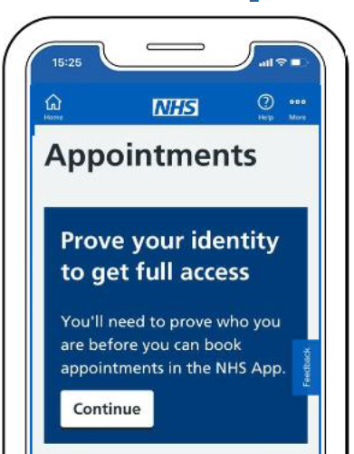 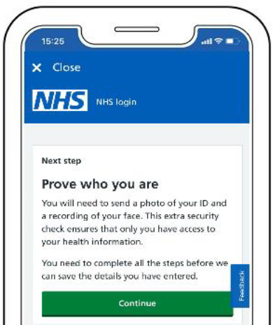

**Photo ID that can be accepted:**

The image you send needs to be of your original photo ID. You cannot send an image of a printout or screen showing your photo ID.

It will accept an expired photo ID if it expired less than 12 months ago.

You can send:

* passport (except Syrian passport)
* UK driving licence (full or provisional)
* European driving licence (full)
* European national identity card (except paper Italian ID card or Greek ID card)
* UK residence card or biometric residence permit (BRP)

**Photo ID that cannot be accepted:**

It will not accept photo ID with any handwritten information other than a signature.

You cannot send:

* travel cards
* bus passes
* NHS ID cards
* visa stickers
* UK citizen ID cards
* proof of age cards
* university or school ID cards
* Syrian passports
* paper Italian ID cards
* Greek ID cards
* UK driver qualification cards
* an image of a printout or screen showing your photo ID

You will be asked to:

1. take a photo of your ID
2. record your face using your device

You will be asked to record your face so that this can compared it to the submitted photo ID and to prove who you are.

After you send your photo ID and video, your photo ID will be carefully checked and this should be done within 2 hours.

If you send between 9pm and 9am it may take longer.

You will be informed by email whether the ID check has been successful.